What should I do If I suspect

**there are bed bugs** in my unit?

* Notify Management Immediately
* Keep records- including dates when and location where pests are found:
* Reduce clutter where bed bugs can hide:
* Physically removing bed bug through cleaning:
* DO NOT go in common areas or visit with friends or neighbors until your unit has been treated:

## FACTS

Early reporting allows the pest to be Identified and treated before the Infestation spread

Tenants are the first line of defense against infestations and should cooperate to create living environments that deter pests.

This includes reducing unreasonable amounts of clutter that create hiding places for pests and deter treatment.

**PLEASE LET THE OFFICE KNOW**

Agency /Pest Control Management should respond with urgency to tenant reports of infestations.

Agency/Pest Control Management should endeavor to take appropriate action within a reasonable time period.

Residents should fully cooperate with agency/ pest control management's efforts to Identify and address infestation.

The tenant cooperation is shown to expedite the control of infestations.

Cooperation Includes allowing agent/pest control management to enter the unit to perform Inspections and treatments, allowing pest treatments to occur, following the pest treatment protocol, and removing Infested furniture or other items from apartment and common areas in specified packages and/or containers.

Residents are advised that some Infestations, including bed bugs, require multiple treatments over the course of several weeks.

**IT'S A TEAM EFFORT!lll**

## BED BUGSII!

As if you needed something else to worry about, bed bugs, those pests from the old bedtime rhyme are making a comeback.

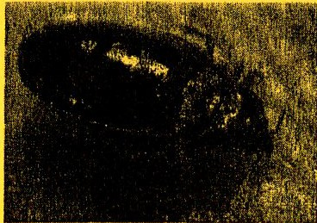

# What are bed bugs?

Bed bugs are small, flat wingless Insects. They feed on blood and can be a nuisance for

Individuals. They are named for their tendency to live on mattresses or other parts of a bed. Bedbugs can be found in homes, apartments, hotels, schools, dormitories, shelters, offices and where lots of people come and go.

**What do bed bugs look like?**

# Know the Enemy!!!

Bed bugs are small, flat, wingless insects with six legs · that, like mosquitoes, feed on